TASK REPORT

Social Links Form UI Styling
Platform icons inside input fields using HTML and CSS

1. Objective
The objective of this task was to improve the appearance of a social links form by placing a recognizable platform icon inside each input field. The design takes inspiration from search and input interfaces that use icons to make fields easier to identify.

2. Implementation
- Created or updated the social-link fields for Instagram, LinkedIn, Facebook, and YouTube.
- Added a platform icon to the left side of each input using icon elements from an icon library.
- Used a relatively positioned wrapper and absolutely positioned icons so the icons sit inside the input area.
- Added left padding to each input to keep typed text clear of the icon.
- Styled the fields with borders, rounded corners, consistent spacing, and a clean white background.
- Previewed the page in a browser using the local development address shown in the screenshot.

3. Result and Visual Evidence
The screenshot shows four vertically arranged social media fields. Instagram, LinkedIn, Facebook, and YouTube each have a corresponding icon inside the left side of the input. The fields use consistent widths, rounded borders, and clear labels. The current screenshot does not show a Submit button.
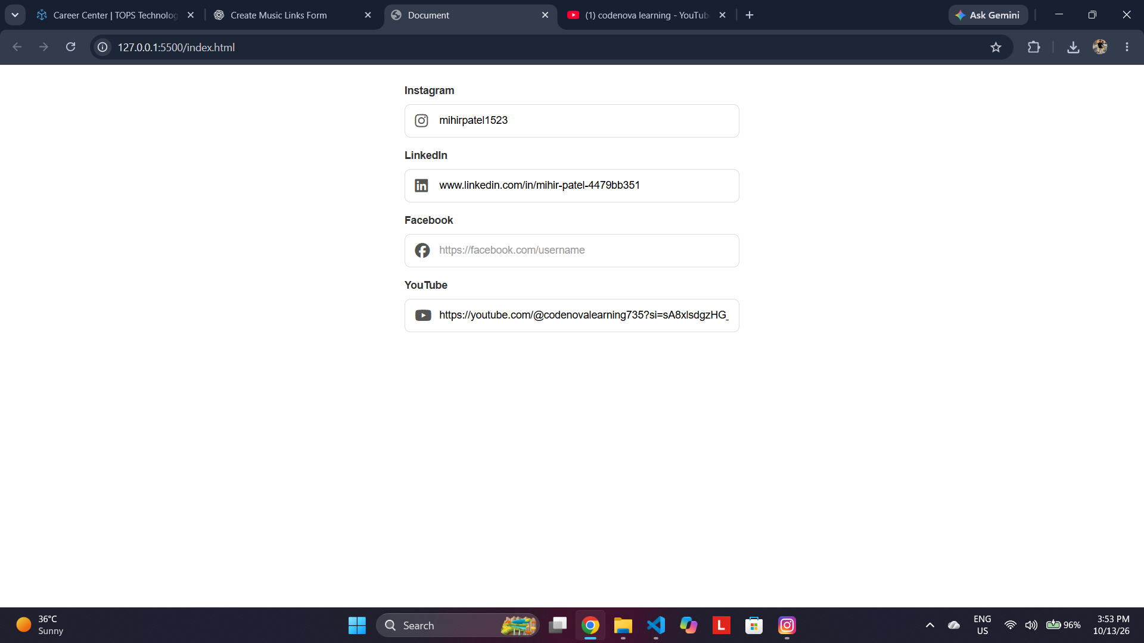
Figure 1. Browser preview of the completed social links form.

4. Testing and Observations
Check | Observation
Platform labels | Instagram, LinkedIn, Facebook, and YouTube labels are visible.
Icon placement | Each input displays a relevant icon on the left inside the field.
Spacing and alignment | Inputs appear consistently aligned with matching widths and spacing.
Text visibility | Entered values and placeholder text appear to the right of the icons.
Submission control | A Submit button is not visible in the supplied screenshot; add one if required by the task.

5. Conclusion
The task successfully demonstrates a cleaner, more user-friendly social links form with platform-specific icons inside the input fields. The layout is simple and consistent, making each social platform easy to recognize. Before final submission, confirm the required behavior of the form and include a Submit button if the assessment expects one.

